

1. Remove existing logo with our logo “ Greeno Network “

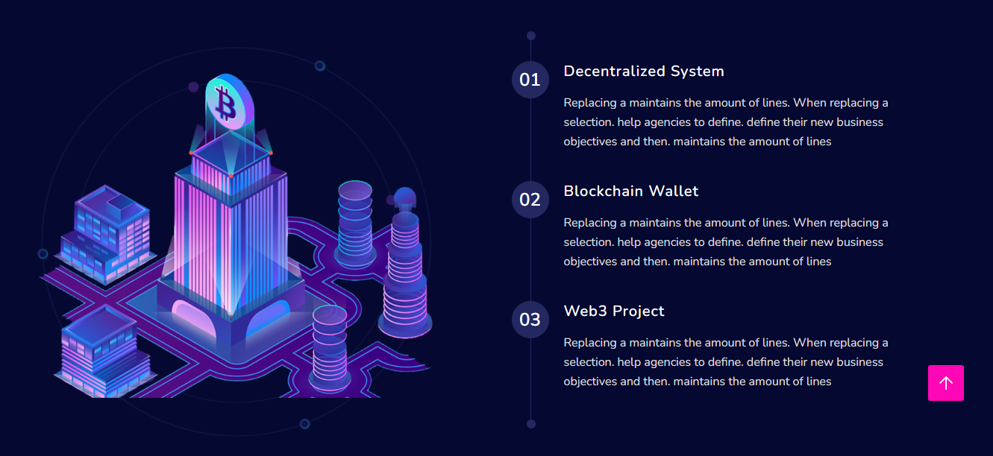

1 . Decentrilized System

A crypto decentralized system is a system where there is no central authority over the network. Instead, each node in the network is responsible for maintaining the network and verifying transactions. This type of system is often seen in cryptocurrencies, where each node in the network is responsible for verifying transactions and maintaining the blockchain.

1. Blockchain Wallet

A blockchain wallet is a digital wallet that allows users to store, send, and receive digital assets such as cryptocurrencies. The wallet is built on top of a blockchain platform and uses cryptography to secure its contents.

1. Web3 Project

A web3 project is a project that uses web3 technology to build decentralized applications (dApps). This allows you to create an experience that is completely different from your normal website.

.



Latest Technology:

Greeno Network will continuous evolution of DeFi and growth of eco-friendly ( Green ) blockchain.

Minning Platform :

We have mining app which is avaliable in Play store and very soon will launch in App store, just like

several other cryptocurriencies use to generate new coins.

Certik Certified :

CertiK is recognized as a leading blockchain auditing firm and security assessment of our smart contract

Which identify vulnerabilities and recomends to fix them.

Metaverse Blockchain:

A metaverse blockchain is a type of distributed ledger that can be used to track ownership of digital assets in a virtual world.

~~Blockchain Provide you the best services~~ : Greeno Network Vision

We offer sustainable living solutions that will make it easy and convenient for you to live a sustainable life. From EV charging stations to organic markets, parks, etc., we have everything you need to make your life more environmentally friendly. We believe that the future is electric, and we're committed to making it a sustainable reality.

As a society, we are becoming increasingly aware of the importance of reducing our carbon footprint. When you think about the environment, what's the first thing that comes to mind?

For most people, it would be conserving energy, reducing greenhouse gas emissions, and saving natural resources. And while these are all important aspects of going green, there's one area of environmentalism that often gets overlooked: parking. Believe it or not, parking can have a significant impact on the planet, but with a little bit of effort, we can all make a big difference.

With that in mind, green car parks are becoming more common as people search for ways to be more eco-friendly. A green park is a parking lot that has been designed to reduce the impact of cars on the environment. Our green parks provide cutting-edge electric vehicle charging stations, organic marts, children's parks, and car care services.



Greeno Park use renewable energy sources like solar and wind power, meaning that they don't rely on traditional sources of energy like petrol and diesel. This makes them much better for the environment, as they don't produce any harmful emissions that can damage the planet. Our mission is to become the one-stop shop for sustainable living, with a focus on renewable energy and electric vehicle charging.

As the world continues to become more and more industrialized, it is also becoming more and more dependent on energy production. And while fossil fuels have been historically used to generate most of the world's energy, they are non-renewable, meaning that they will eventually run out. In fact, we are already starting to see the effects of this depletion, with rising energy costs and an increased reliance on unstable regions for oil supply.

This is why sustainable renewable energy is so important. The world is in dire need of sustainable, renewable energy sources. Fossil fuels are finite and emit harmful greenhouse gases into the atmosphere which contributes to climate change. Renewable energy sources like solar and wind power are inexhaustible and don't produce emissions, making them the ideal solution for our energy needs.

Thankfully, we are quickly becoming more and more reliant on sustainable renewable energy. The benefits of renewable energy are innumerable, and its impact on the environment is nothing short of astounding. Renewable energy is growing more affordable and accessible all the time, as noticed by the growing number of renewable energy projects happening across the globe. What was once an expensive alternative to traditional energy sources is quickly becoming a more cost-effective option.

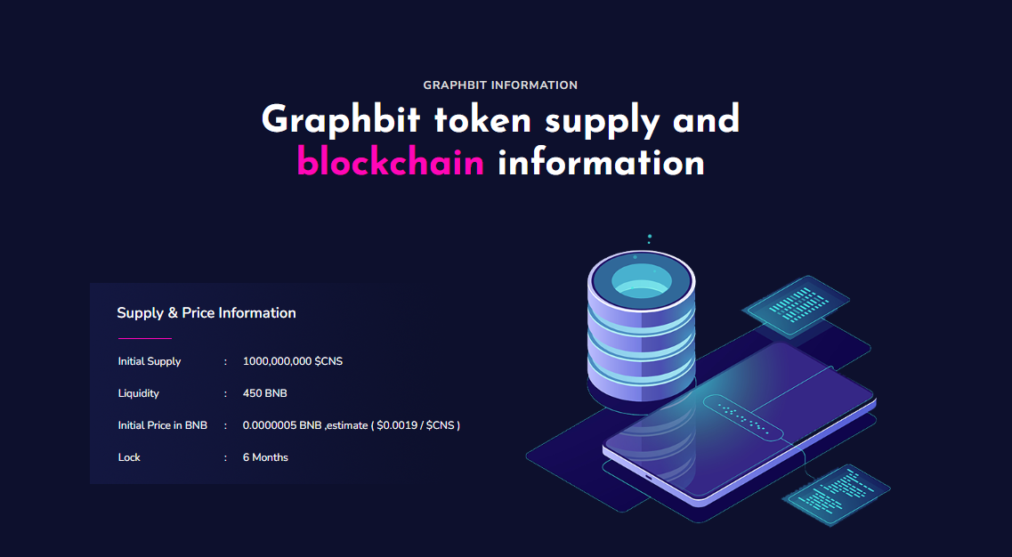

Greeno Network Information

Greeno Network token supply and blockchian Information

Initial Supply : 100 Billion

Liquidity : 500 BNB

Initial price in BNB : N/a

Lock : Life time

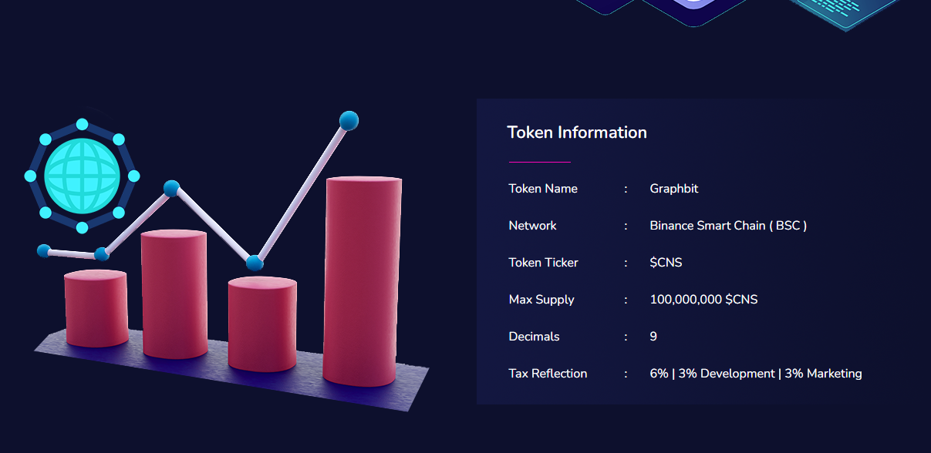

Token Name : Greeno Network

Network : Binance Smart Chain ( BSC )

Token Ticker : N/a

Max Supply : 500 Billion

Decimals : 18

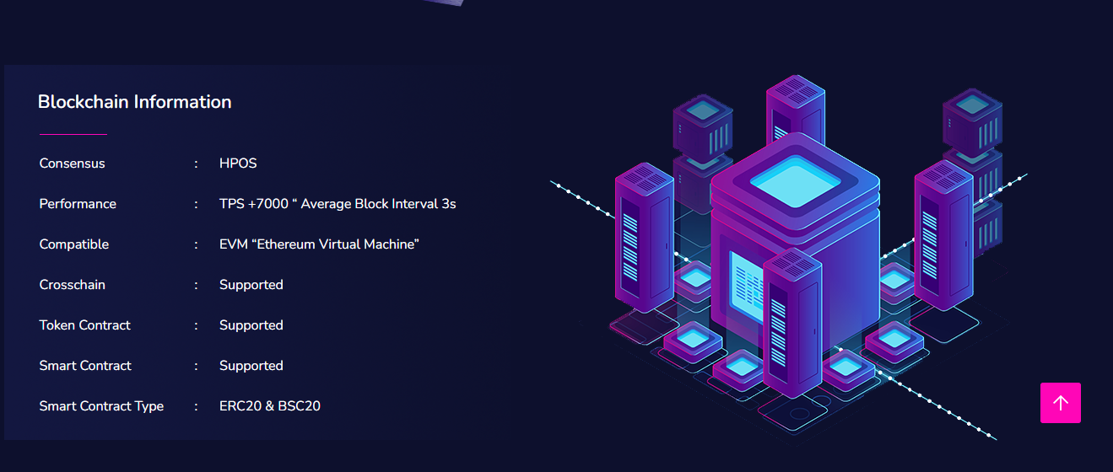

Consences : PoA ( Proof of activity )

Performances : TPS+7000 ( Block interval 3sec )

Compatible : EVM ( Ethereum Virtual Machine )

Crosschain : Supported

Token Contract : Supported

Smart Contract : Supported

Smart Contract Type : ERC20 & BSC20



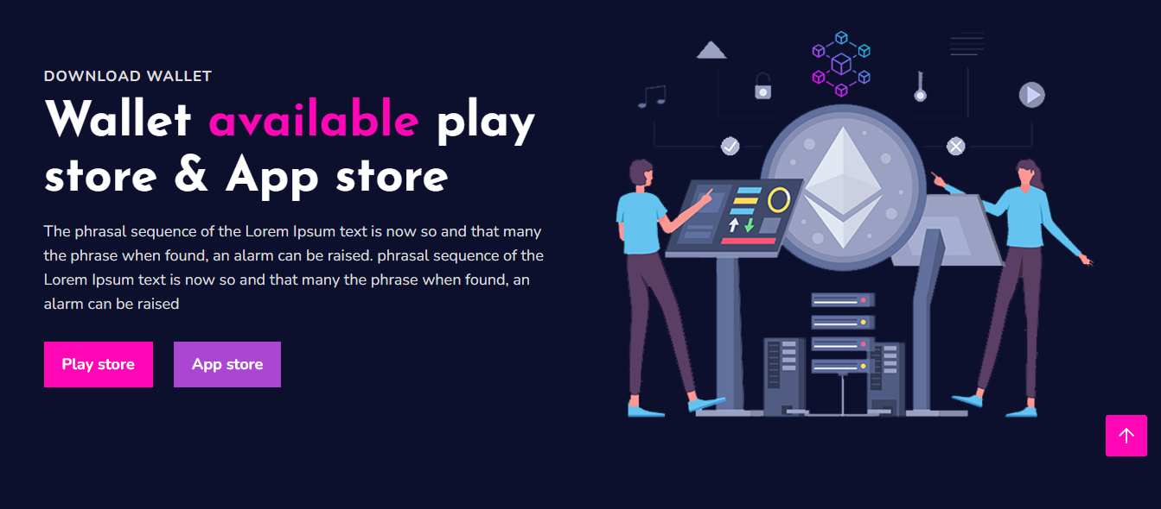

Download ~~wallet~~ mining App

Play Store link : <https://play.google.com/store/apps/details?id=com.allgreeno.network.miner>

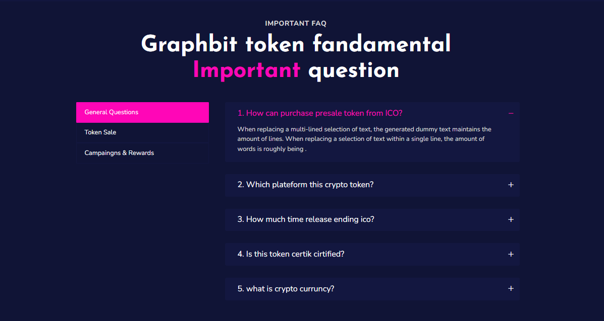

Greeno Network fundamental Important Questions :

#### ****General Questions :****

#### ****What are cryptocurrencies?****

[Cryptocurrencies](https://www.investopedia.com/terms/c/cryptocurrency.asp) are a digital asset that started as a medium of exchange for people to buy goods and services. Over time, their functionality has expanded.

#### ****How are cryptocurrency transactions recorded?****

Cryptocurrency transactions are recorded on a shared, digital ledger called a blockchain. This is decentralized technology, spread across many computers, that records every transaction.

#### ****Are blockchain and cryptocurrencies the same?****

No. Blockchain is the technology that allows for cryptocurrencies to work. It is a decentralized and digital ledger of transactions used for cryptocurrencies and other assets/functions. It is important to separate the technology behind cryptocurrencies from the actual cryptocurrencies.

#### ****What is a crypto wallet?****

Simply put, crypto wallets are places to store digital assets more securely than just on an exchange.  You hold your wallet via an exchange account, custody wallet, or outside of the exchange. You can establish an online or “hot” wallet that is internet connected—to your desktop, table or mobile phone. There is also the option to store on a device that is not connected to the internet (“cold” wallet). Cold wallets are the most secure way to store your cryptocurrency, but they are meant for longer-term holdings as they are not connected to the internet. With cold storage, you must remember your private keys (identifier number for your cryptocurrency).

### What are public and private keys?

The next important addition among best questions about crypto would draw attention towards the basic elements in working of cryptocurrencies. The primary foundation of Bitcoin and other notable cryptocurrencies is [public-key cryptography](https://101blockchains.com/public-key-cryptography/). According to the cryptographic system, two different types of keys, such as public key and private key in pairs, can support crypto transactions. The public keys are important for identification and should be publicly visible. On the other hand, the private keys help in authentication and encryption, thereby implying that they are secret in nature.

Greeno App :

1. What is Greeno Coin ?

Greeno Coin is a payment solution for all greeno park outlets and you can pay these coins for charging your electric vehicle and much more.

1. Does mining effect my device ?

No, your device will not eat your battery or any kind of resources.

1. How to gain more Greeno Coins ?

Keep mining daily and refer as many friends as you can.

1. Why I am unable to login in the app ?

Sometime due to heavy traffic , Server is unable to take load. But we assure you in future it will be fast and more exicting features will be added.

1. When can we withdraw our coins ?

We have covered it Road map , please go through it.



Telegram : t.me/greenonetwork

Instagram : @greenonetwork